LAB 1

OBJECT:

Setting up the system to run ASP Files

THEORY:
In order to run ASP files, we need some initial steps to configure a machine residing these files.
REQUIREMENTS:
- Internet Information Services (IIS) or Personal Web Manager (PWM)
- Virtual Directory
PROCEDURE:
INSTALLING IIS:
- Go to Start -- > Settings - > Control Panel -- > Add/Remove Programs

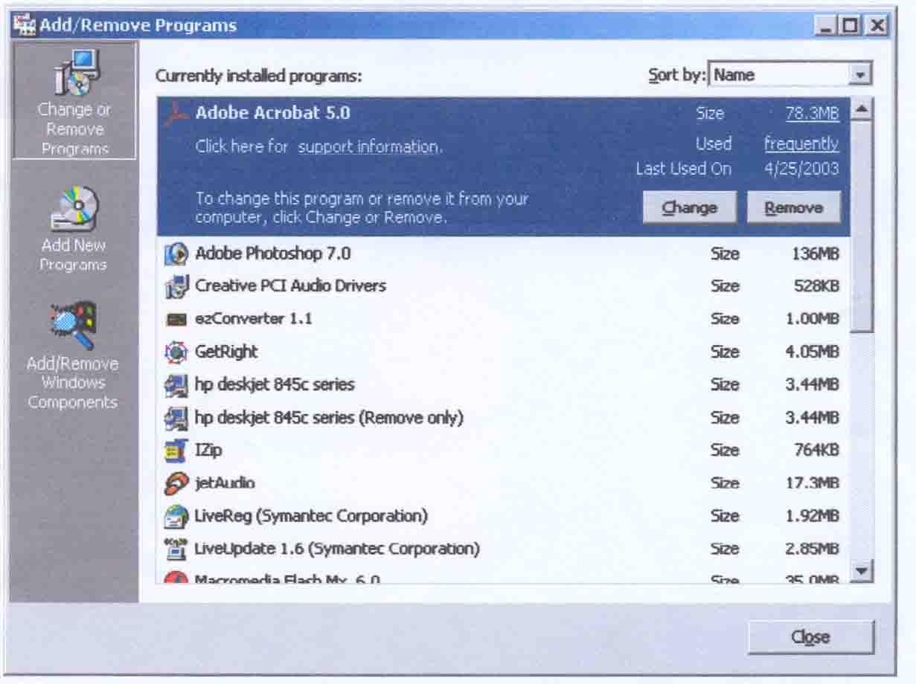
2 Click Add/Remove Windows Components and Check Internet Information Services (IIS)

